**CCNA Lecture 01:**

**What is Network?**

A network is a collection of two or more interconnected computers or devices that can communicate with each other and share resources such as data, files, printers, and internet connections.

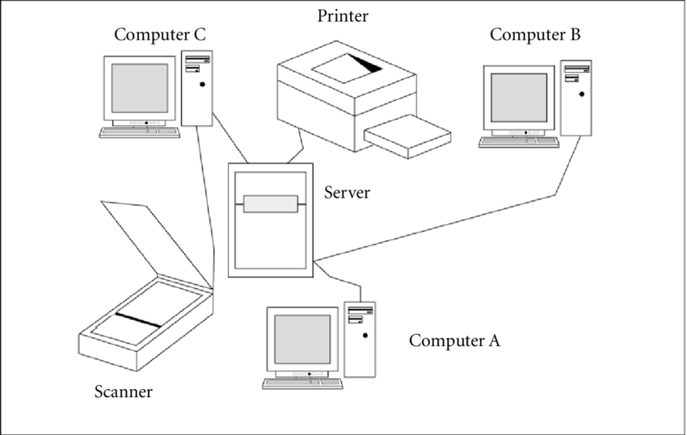

**First Computer Network:**

**ARPANET->** Advanced Research Projects Agency Networks

**Features of Computer Network:**

* Resource Sharing
* Communication Speed
* Backup
* Scalability
* Reliability
* Software and Hardware Sharing
* Security

**Networking Devices:**

Hub, Routers, Switches, Modem, Gateway, Repeater

**Basic Elements of a Network**

|  |  |
| --- | --- |
| **Element** | **Description** |
| **Devices** | Computers, phones, printers, servers |
| **NIC** | Network Interface Card (inside every device) |
| **Cables/Wi-Fi** | Medium that connects devices |
| **Switch** | Connects devices inside a LAN |
| **Router** | Connects different networks (e.g., home to internet) |
| **Access Point** | Provides wireless connectivity |
| **Firewall** | Controls traffic, provides security |

**Types of Networks**

|  |  |  |
| --- | --- | --- |
| **Type** | **Name** | **Description** |
| **LAN** | Local Area Network | Inside homes, offices, schools |
| **WAN** | Wide Area Network | Covers large geographical area (e.g., Internet) |
| **MAN** | Metropolitan Area Network | Within a city (e.g., university network) |
| **PAN** | Personal Area Network | Small personal space (e.g., Bluetooth devices) |

**Topologies:**

The physical arrangement of the computer system/node, connected to each other via communication medium called topology.

**Bus Topology:**

In bus topology, one long single central cable act as a single communication channel and all the devices are connected to this cable.

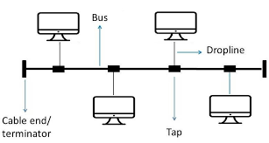

**Advantages:**

* Easy to add or remove nodes in a network.
* Less Expensive
* Broadcast message to each device connected through the cable
* In case of any failure in single computer, there will be no effect on other devices.

**Disadvantages:**

* If there’s some failure occur in cable, it will be effect whole network.
* As message broadcast, so we can’t send private messages.
* Take more time to pass message from one place to another.
* Length of cable is limited.
* In this topology, **only one device can transmit at a time, otherwise collisions occur.**

**Ring Topology:**

It is called ring topology because it forms a ring. In this topology, each node strongly connected with its adjacent node.

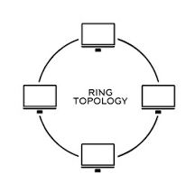

**Advantages:**

* It forms a strong network.
* Every node can share data with other connected through a ring topology.
* Transmission rate of data is very high.
* The data send through it will be broadcast.

**Disadvantages:**

* Difficult to add new devices.
* If we want to send data from source to destination, it will may or may not be passed through all nodes.
* Single point of failure means entire network failed.
* Can’t send private messages.

**Star Topology:**

In star topology, all nodes are connected with a controllable device called Hub/Switch and sharing of data can only possible through it.

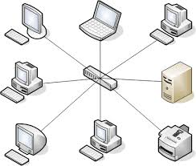

**Advantages:**

* It broadcast the messages.
* Less expensive due to less cable.
* Easy to connect new nodes without affecting rest of the network.
* If one node fail, entire network will be failed.

**Disadvantages:**

* In star topology, we must require network device like Hub, Switch etc.
* If two nodes want to share data, it will be only possible thorough these devices.
* If Hub or switch fail, entire network will be failed.
* We can’t send private messages through it.

**Mesh Topology:**

In this topology, each and every computer is directly connected with each other so we can directly send data to the destination machine, without going to the intermediate machine.

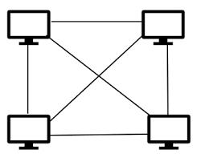

**Advantages:**

* Good to send private messages.
* All nodes directly associated with one another so it provide point to point connection.
* Unlike ring topology, if one machine fail entire network will not fail.
* Multiple devices can send and receive data simultaneously.

**Disadvantages:**

* Difficult to add new nodes because each and every computer directly connect with each other.
* If particular machine fails, we can’t send and receive data through it.

**Hybrid topology:**

Combination of various different topologies.

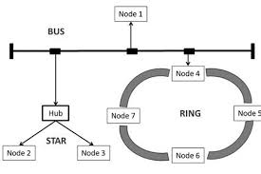

**Tree topology:**

In this topology, all the nodes connected like branches of tree. Combination of Bus and Star topology called tree topology.

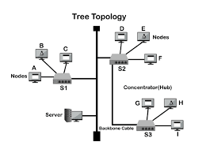

### **Use Cases:**

* Home networks with multiple devices
* Office LANs
* School computer labs
* Any environment where **ease of troubleshooting and control** is important

**Data Transmission: (Based on Number of receivers)**

## **1. Unicast (One-to-One)**

Unicast is a **one-to-one communication** between a single sender and a single receiver.

**Example:**

A computer sends an email to another specific computer.

### Details:

* Most common type of communication on networks.
* Used in normal web browsing, file transfers, etc.
* Efficient for point-to-point communication.

### Example in IP:

* Source IP: 192.168.1.2
* Destination IP: 192.168.1.3

## **2. Broadcast (One-to-All)**

## Broadcast is a **one-to-all** communication where a message is sent from one device to **all devices** in the same network segment.

### Example:

A DHCP Discover message is broadcast to all devices on the local network.

### Details:

* Only works within the same subnet.
* Can lead to **network congestion** if used excessively.
* IPv4 supports broadcast; **IPv6 does not**.

### Broadcast IP:

* 255.255.255.255 – limited broadcast
* 192.168.1.255 – directed broadcast (for a subnet)

## **3. Multicast (One-to-Many)**

## Multicast is a **one-to-many** communication where data is sent to a **specific group** of interested receivers.

### Example:

Streaming a live video to many subscribers on the same network.

### Details:

* Efficient for group communication (uses less bandwidth than unicast).
* Used in video conferencing, IPTV, online lectures, etc.
* Devices must **join a multicast group** to receive the data.

### Multicast IP Range:

* 224.0.0.0 to 239.255.255.255 (Class D IPs)

## **4. Anycast (One-to-Nearest One)**

## Anycast is **one-to-nearest** communication. A message is sent to **multiple receivers**, but **only the closest one** (in terms of routing distance) responds.

### Example:

DNS query sent to a global Google DNS server (8.8.8.8) — it goes to the **nearest server** geographically.

### Details:

* Used for **load balancing**, **high availability**, and **failover**.
* Common in **IPv6** and **CDNs (Content Delivery Networks)**.
* Optimizes speed and reliability.

**Data Transmission: (Based on Number of Synchronization)**

**Synchronous:**

A lot of data sent in a block. Each block has many characters.

Faster and more efficient

**Asynchronous:**

In this transmission, only one character is sent at a time, whether it is a character, number or alphabet.

Simpler, but slower

**Data Transmission: (Based on How data flow)**

**Serial Data Transmission:**

* Slow
* Long time
* Less Expensive

**Parallel Data Transmission:**

* Fast
* Short time
* More Expensive